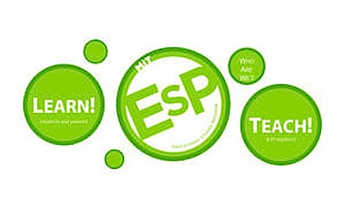

Class Title: S15091

Astronaut Health:
Optimization of Human Performance for the Extreme Environment of Space

Semester and Year: HSSP Summer 2022
Day/Times: Saturdays, July 9th – August 13th
Format: Online Web Conference (Zoom)
Faculty: Dr. Ekaterina Kostioukhina, MD
Category: Science
Course Description and Learning Objectives:
The astronauts' body is the biological machinery that must sustain the harsh task of space exploration. This six-week course will explore the challenges and dangers that the human body is exposed to in the extreme environment of space and other locations outside of our home planet. We will review the training that astronauts go through to prepare for their journey, the mitigation strategies that they use during the missions, and the post mission recovery treatments that they receive upon returning to Earth.

Saturday, July 9th | Introductions and class overview.  Teamwork and Collaboration Activity.
Saturday, July 16th | Where are we going and when?  Lunar colonization, Mars projects and Space Tourism.
Saturday, July 23rd | Optimization of the biological machinery: preparing your body while on Earth.
Saturday, July 30th | The effects of space on the human body: what can go wrong and how to fix it.
Saturday, August 6th | Optimization of the brain software: resiliency and grit.
Saturday, August 13th | Conclusions and inspiring stories.
Great Reading materials
(Optional)

Hadfield, Chris. (2013). An astronaut's guide to life on earth. Random House Canada.

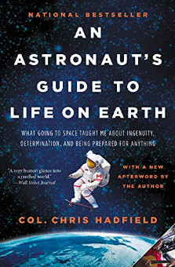
Col. Hadfield takes readers deep into his years of training and space exploration to show how to make the impossible possible. Through eye-opening, entertaining stories filled with the adrenaline of launch, the mesmerizing wonder of spacewalks, and the measured, calm responses mandated by crises, he explains how conventional wisdom can get in the way of achievement — and happiness. His own extraordinary education in space has taught him some counterintuitive lessons: don't visualize success, do care what others think, and always sweat the small stuff. The secret to Col. Hadfield's success-and survival-is an unconventional philosophy he learned at NASA: prepare for the worst- and enjoy every moment of it.

Hernandez, & Rubin, M. R. (2012). Reaching for the Stars the Inspiring Story of a Migrant Farmworker Turned Astronaut. Hachette Nashville.

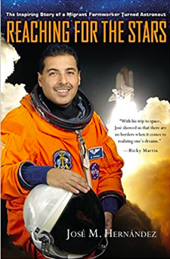
Born into a family of migrant workers, toiling in the fields by the age of six, Jose M. Hernàndez dreamed of traveling through the night skies on a rocket ship. Reaching for the Stars is the inspiring story of how he realized that dream, becoming the first Mexican-American astronaut.
Hernàndez didn't speak English till he was 12, and his peers often joined gangs, or skipped school. And yet, by his twenties he was part of an elite team helping develop technology for the early detection of breast cancer. He was turned down by NASA eleven times on his long journey to donning that famous orange space suit.
Hernàndez message of hard work, education, perseverance, of "reaching for the stars," makes this a classic American autobiography.

Melvin, Leland. (2017). Chasing space: Young Reader's Edition (First edition.). Amistad, an imprint of Harper Collins Publishers.

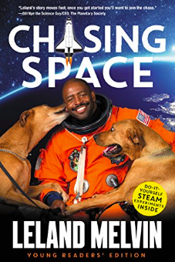
Meet Leland Melvin—football star, NASA astronaut, and professional dream chaser.
In this inspiring memoir, adapted from the simultaneous version for adults, young readers will get to learn about Leland Melvin’s remarkable life story, from being drafted by the Detroit Lions to bravely orbiting our planet in the International Space Station to writing songs with will.i.am, working with Serena Williams, and starring in top-rated television shows like The Dog Whisperer, Top Chef, and Child Genius.
When the former Detroit Lion’s football career was cut short by an injury, Leland didn’t waste time mourning his broken dream. Instead, he found a new one—something that was completely out of this world.
He joined NASA, braved an injury that nearly left him permanently deaf, and still managed to muster the courage and resolve to travel to space on the shuttle Atlantis to help build the International Space Station. Leland’s problem-solving methods and can-do attitude turned his impossible-seeming dream into reality.
Leland’s story introduces readers to the fascinating creative and scientific challenges he had to deal with in space and will encourage the next generation of can-do scientists to dare to follow their dreams.

Gerardi, Kellie. (2020). Not Necessarily Rocket Science. Mango Media.

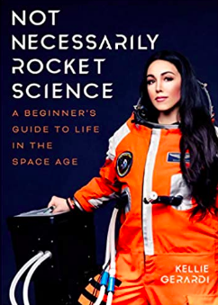
Follow aerospace science professional Kellie Gerardi’s non-traditional path in the space industry as she guides and encourages anyone who has ever dreamed about stars, the solar system, and the galaxies in space.
Ever wondered what it’s like to work in outer space? In this candid science memoir and career guide, Kellie Gerardi offers an inside look into the industry beginning to eclipse Silicon Valley.
What it’s like to be a woman in space. With a space background and a mission to democratize access to space, this female astronaut candidate offers a front row seat to the final frontier. From her adventures training for Mars to testing spacesuits in microgravity, this unique handbook provides inspiration and guidance for aspiring female astronauts everywhere.

One Strange Rock Documentary
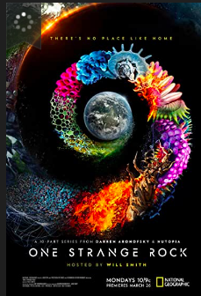
The extraordinary story of Earth and why it is special and uniquely brimming with life among a largely unknown but harsh cosmic arena; astronauts tell the story of Earth through a unique perspective.

